Cold Cap & Chemo Guide  Colorado Cold Cap Therapy | 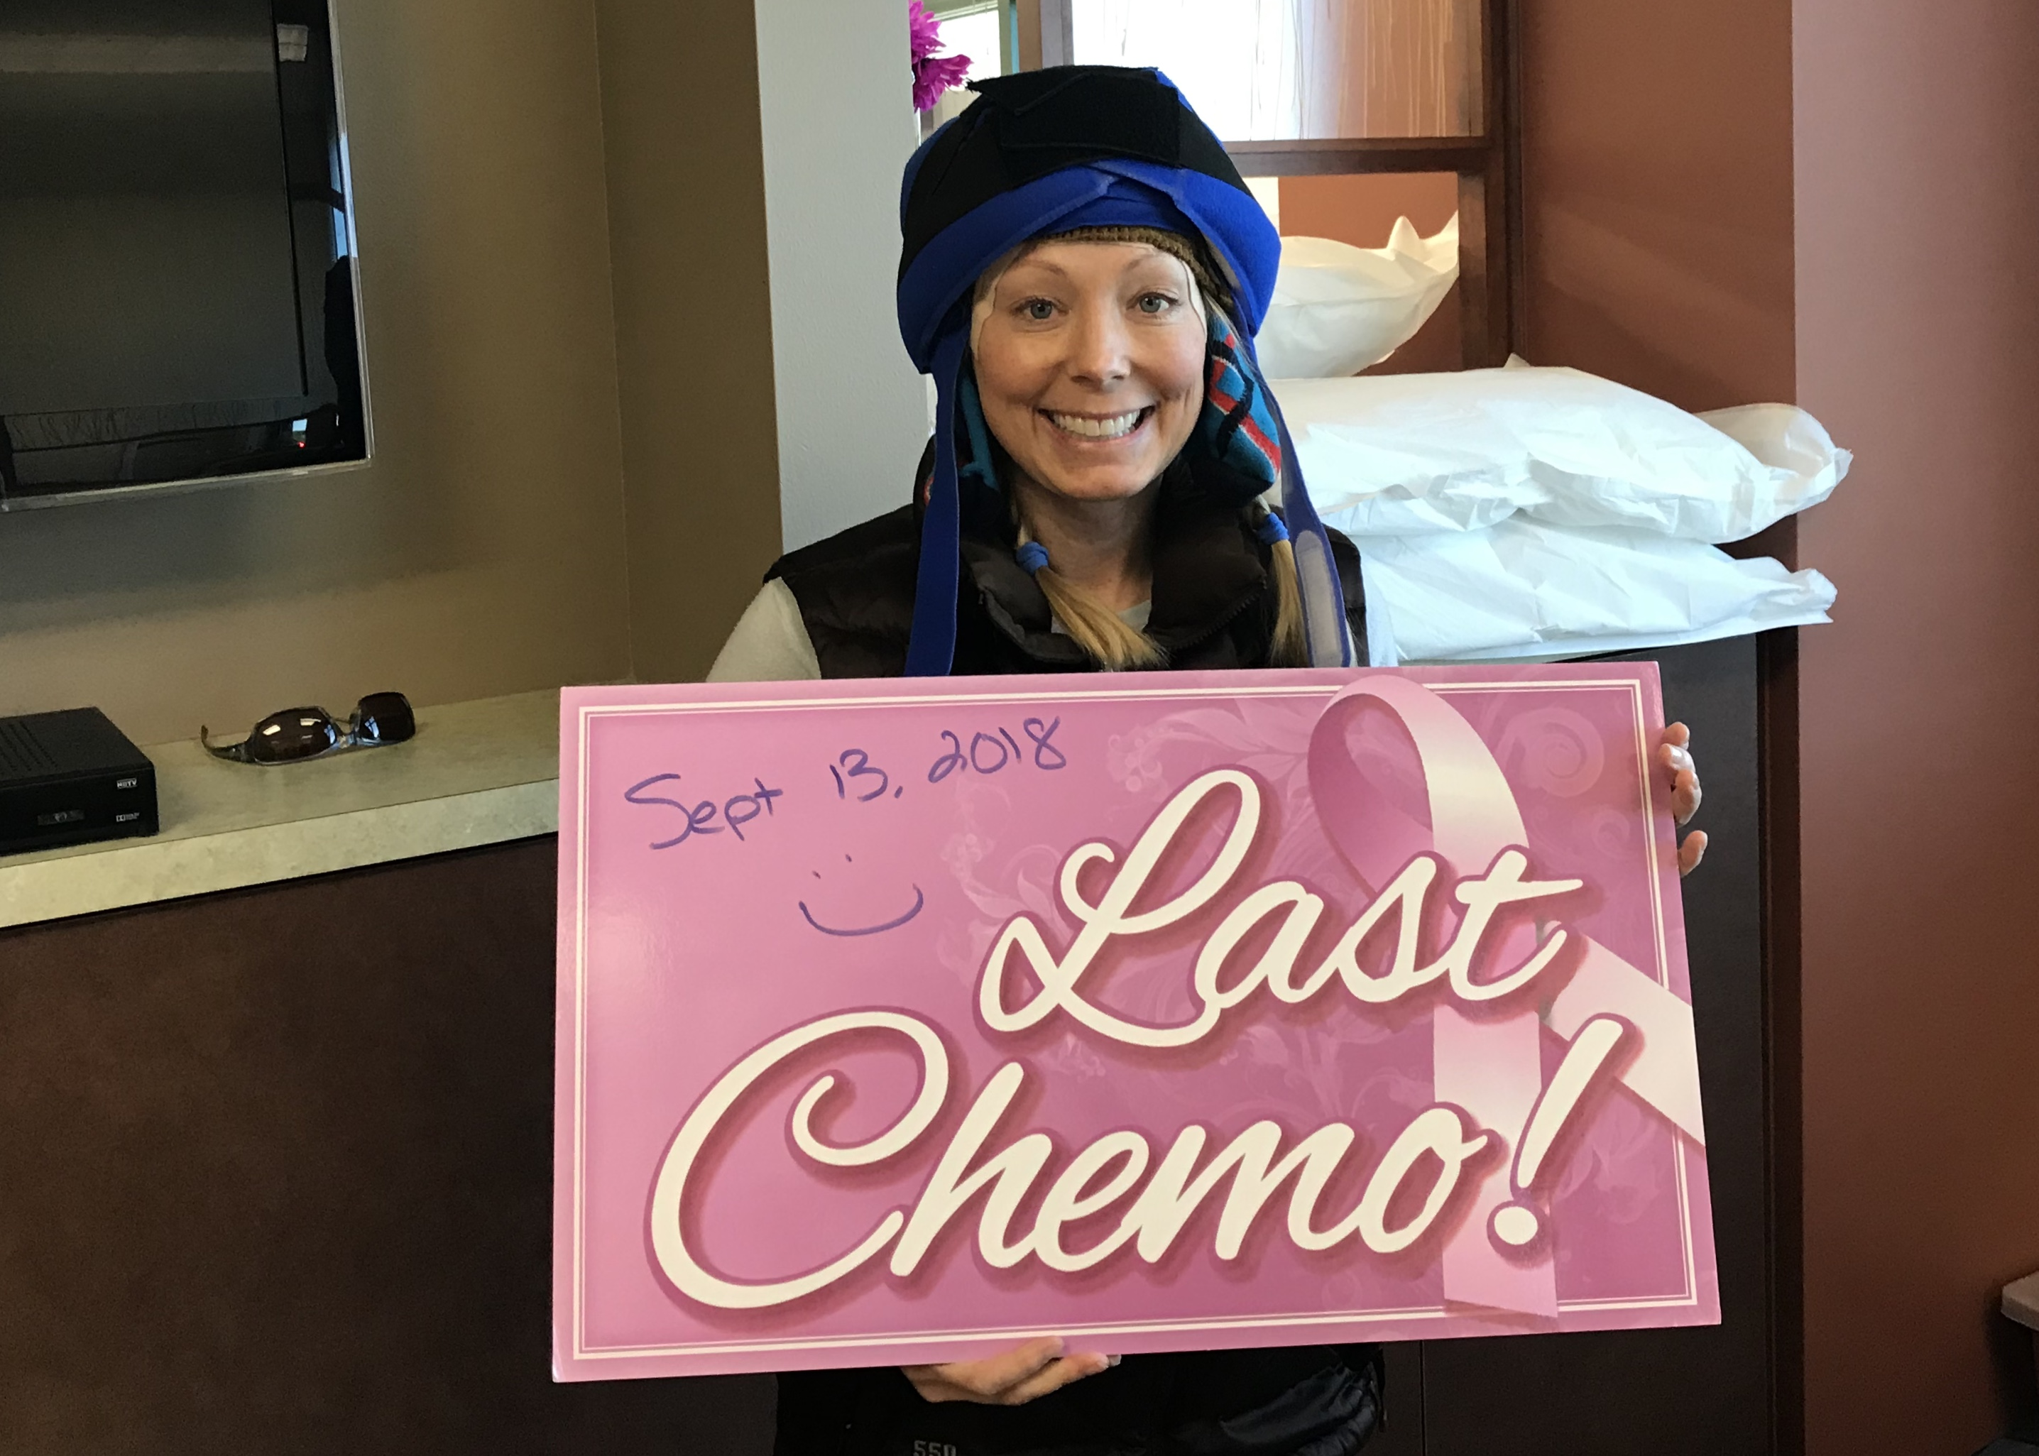
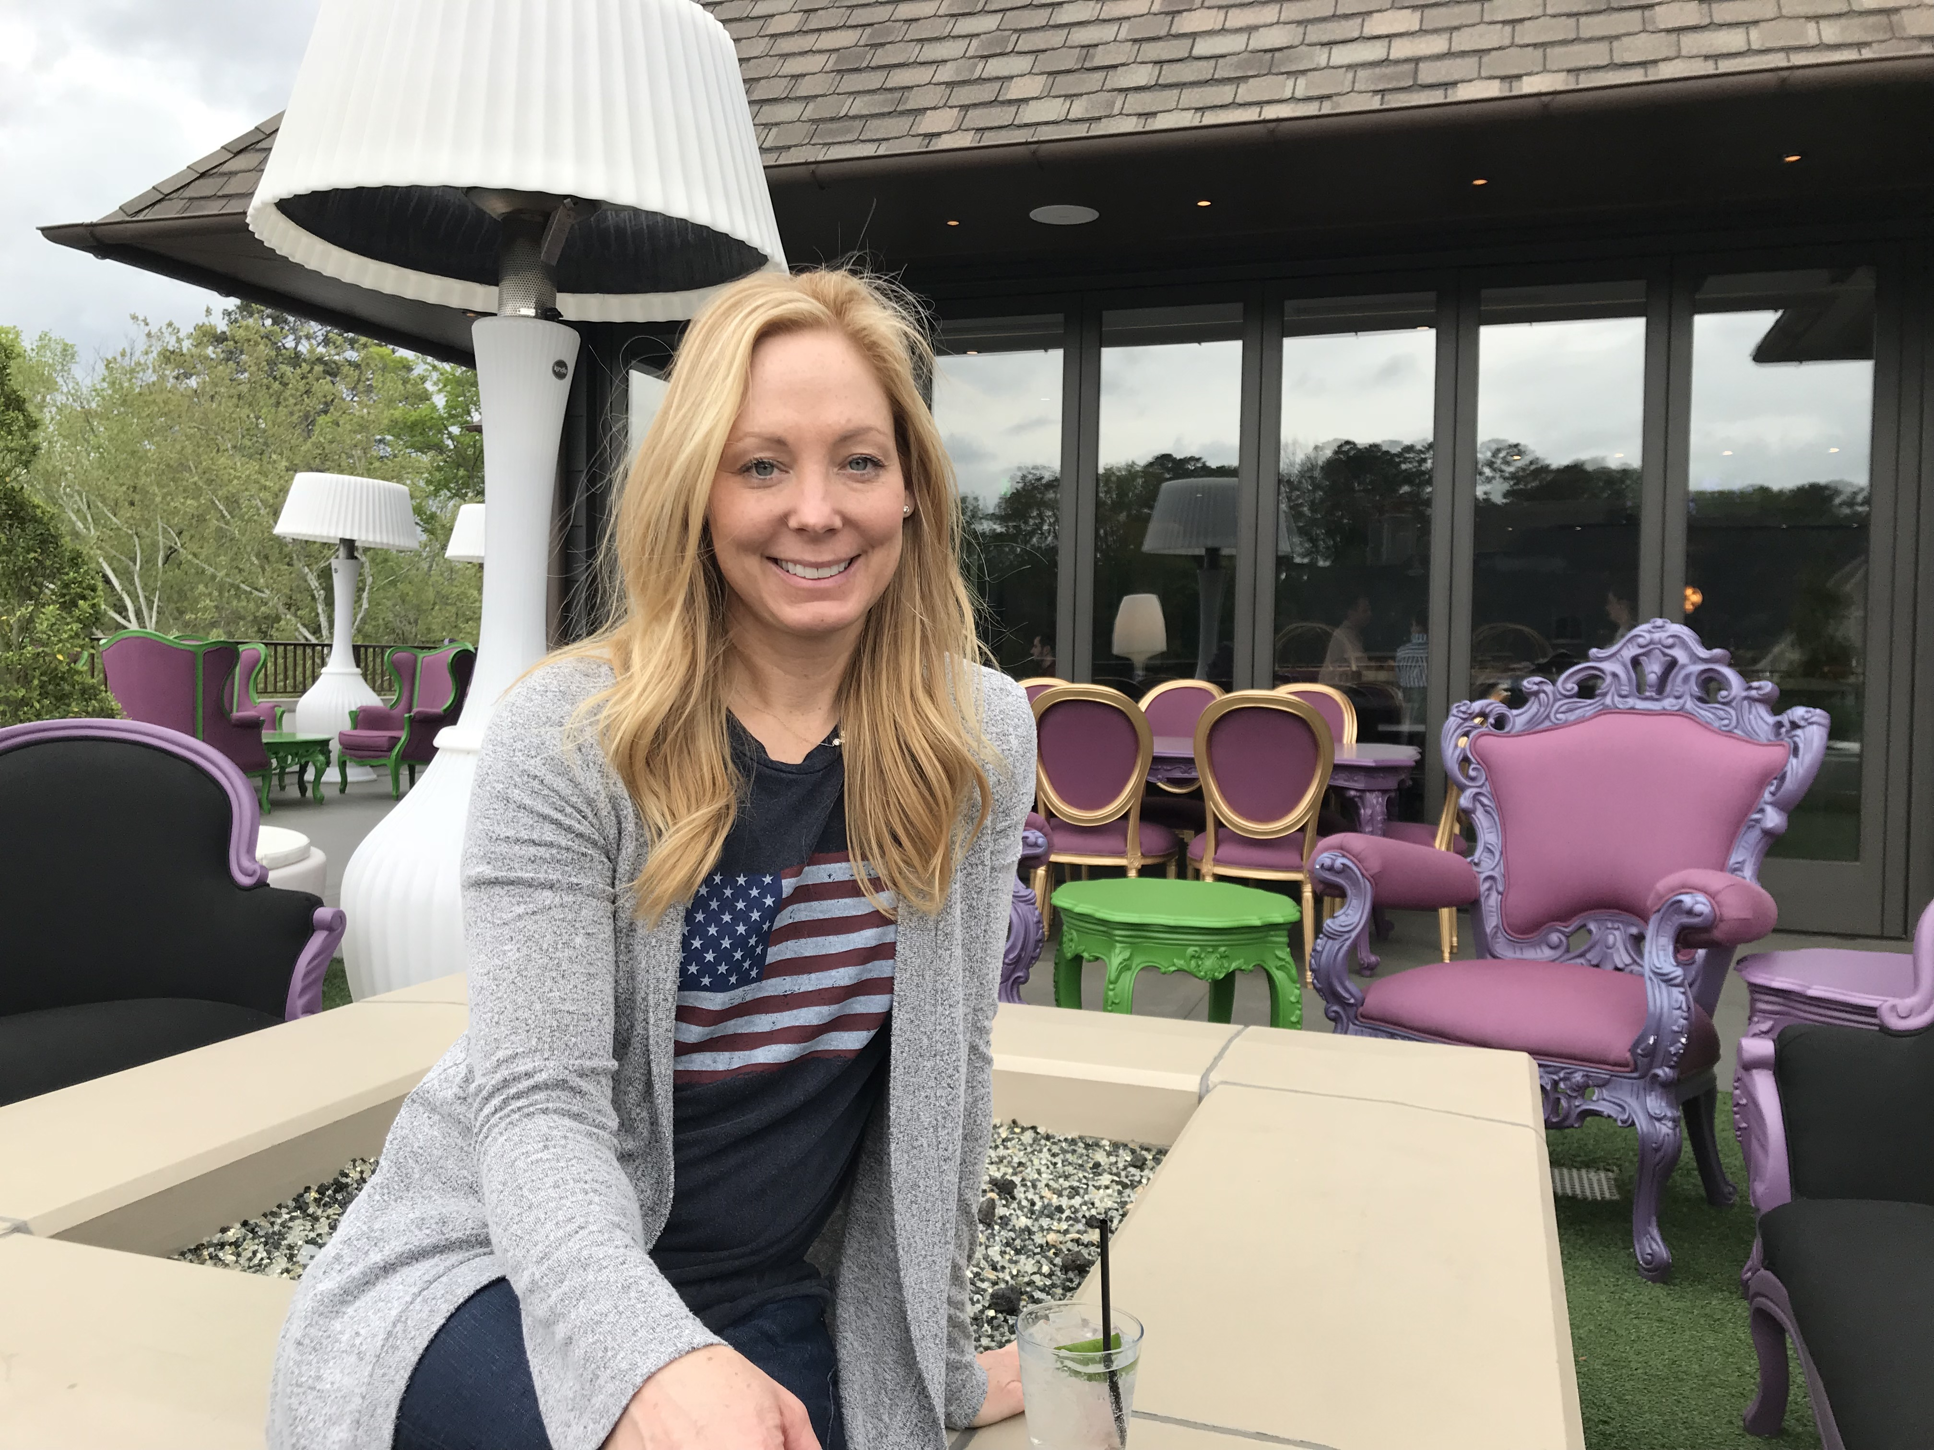  One Week Pre-Diagnosis | 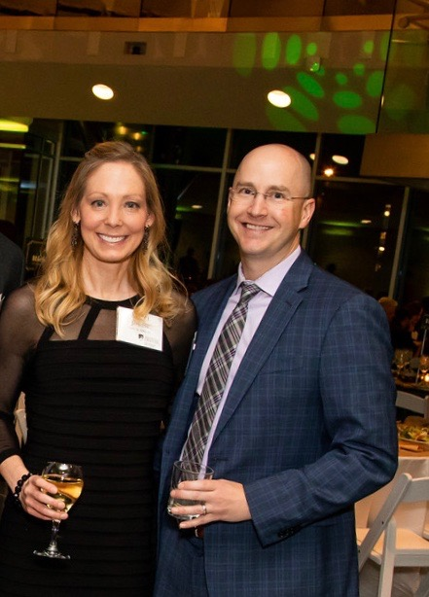  Two Months Post-Chemo (my own hair!)

  - C0ld Caps can give you a feeling of being “normal” when nothing is normal…
There are many different reasons why women choose to use Cold Caps, mine was so my kids would not freak out and think I was really sick and be scared, and because I was starting a new job and didn’t want people feeling sorry for me. Whatever your reason – it’s your choice… know whatever you choose is the right decision for you!

What is Cold Capping and how does it work?

How does the Cold Cap work?
When you get chemo, the toxins go throughout your body and attack the fast growing/multiplying cells. Your hair is one of those fast growing areas of the body… by cooling your scalp during treatment (actually freezing it) you reduce the amount of blood flow to the hair follicle, which in turn prevents chemo from getting into the follicles. Some follicles, mostly the older hairs on your head that would have fallen out naturally in the next 3-6 months (we all lose hair every day), will still be affected by the chemo – but in my case, I kept 75-80 percent of my hair and had NO bald spots. I did “shed” hair starting around days 14-21 after the first treatment, and continued to see shedding until about 3 months post treatment. But… it was not clumps. And… no one but me even noticed.

Why are there different types of Cold Caps?
There are different manufacturers out there who have created caps based on this scalp cooling approach. Some are caps that fit and stay on your head the entire time, others are caps you have to swap out every 25/30 minutes. Based on my experience and talking to other patients, the caps that require more effort (swapping out the caps every 25/30 min and forming the cap around your head), like the Penguin cap, seem to have the best results. But I do know individuals who have used other caps like Digny Cap and Paxman who have had great results, especially when the pre-sized caps fit their head shape very well.

How much does it cost?
Some cold caps can be covered by insurance if your doctor will code them as “ice bags” or something similar but… if not the cost for Penguin Caps is $500 per month. The other cap manufacturers costs are similar.

What does a typical chemo day look like when using the cap?
Pre-Appointment To-Dos:
- Don’t wash your hair two days before chemo – you want the natural oils in your hair.
- You will probably want to have 1 or two people to be your “helpers” for the day. My husband and a friend helped me. The nurses will be supportive but will not play a role in helping you with the cap, unless you find a great center that really promotes using the caps.
- If your facility does not have a biomedical freezer that you can use (many places do not) you will need to pick up five 10 pound slabs of dry ice the morning of your treatment. This cooler works great (60 quart rolling cooler). General Air in Colorado typically donates dry ice for chemo patients, just ask when you call to confirm they have it the day before your treatment.
- Since your head will be frozen during your treatment and for several hours after, it is best to wear layers including maybe a warm vest to keep your body temperature up. You also may want to make sure you are drinking hot tea while wearing the cap – the liquids will help your body flush the chemo anyway.

During Your Infusion Appointment:
- When you arrive at the center for your infusion, your helpers should put the first cap into the cooler with dry ice while you get blood work/meet with the doctor. They will add the 2nd cap after 20 minutes and the 3rd cap after 20 more minutes.
- Once you finish with the doctor and have the results of your blood work, your helpers will get your head ready for the cap using moleskin for your forehead and temples (cut the moleskin to fit on your forehead and temples), kids socks (any will do) for your ears, gauze for your part, and a hair net to keep the Velcro from sticking to your own hair.
- Once the first cap has been in the ice for 50 minutes, you can put it on your head and start the pre-cooling period (following the instructions provided by the manufacturer for temperature and times).
- Tell your nurses when you start pre-cooling and that you need about 50 minutes before starting the chemo infusion.
  - Typically they will start the pre-meds wich 15/20 min left of your pre-cooling period.
  - The only thing that really matters is that they do not start chemo until you have pre-cooled your head for at least 50 minutes.
  - If they are not quite ready at 50 minutes, no worries – going longer before chemo is fine.
- Once pre-cooling is done, then they can start chemo.
- Many chemo sessions take approx. 2 hours but that can vary. Make sure to drink lots of water or tea (ideally hot) during your chemo and after. The more you have to pee the better!
- Once your chemo is done, note the time you finished, as you will need to keep wearing the cap for several more hours (typically 4 hours but the manufacturer will tell you exactly how long to wear the cap post chemo).
- Your nurses can unhook your port/IV and get you ready to leave.
- Once the nurses are done, and if you are using the Penguin Cap you can swap out a cap then head to your house or another location where you plan to finish capping for the day. Make sure you can make it to your next location before the 25 minutes are up. If you are using one of the caps that the center has hooked up to a cooling source, you will stay at the center to finish your cooling period post chemo completion.

What happens after you finish with a Chemo treatment?
- When you are finished capping, it will take about 20-3o min for your head to fully thaw (it feels so good once it is!)
- You should not wash your hair for 3 days post chemo, and only wash it every 2-3days after that and through the remainder of your time getting treatment – but before each chemo you stop washing 2 days before and don’t wash for 3 days after,
- When you do wash your hair – I found it easiest to turn on the shower to lukewarm (you don’t have to use cold but you don’t want it warm or hot) and lean back and rinse your hair then use a really gentle shamp00 and conditioner that do not have sulfates, parabens, etc. Then you can turn the temp back up to finish showering.
- I also would put a leave in conditioner on my hair – I loved the Davines OI Oil or Morocan Oil Light, they are light and did not weigh my hair down.
- About 14-21 days post EACH treatment you WILL experience some shedding, and it will continue throughout your treatment, but the goal is no large clumps (at most I had maybe 15-20 hairs come out together in the shower but it looks like more wet and clumped together than it really is since the hair is coming from all over your head.
- Just stick with the careful washing and only every 2-3 days… it will be over before you know it and your hair will start to feel normal Mine did about 3.5 months post-my last treatment.
What else can I do to help me get through chemo?

Additional things that helped me after chemo:
- Exercise – I made sure to do 30-40 min walks every day regardless of how I felt. On days I felt better I went for a run or rode the stationary bike. I would try and keep my head as cool as possible by either wearing the cold cap from the freezer during a stationary bike ride or putting it on for a few minutes after a run or other workout. If I was not near the caps, I would poor ice/cold water on my head to cool it down. Exercise is key to not only flushing the chemo but to helping your cells recover from the impact.
- Eat Healthy - I found that when nothing sounded good – I could down these smoothies (you can get them at whole foods or via Amazon) that were created by a fellow cancer survivor: Orgain Protein Shakes. Once my appetite came back, I really focused on eating lots of veggies and fruits and still drinking loots of water. Also – I found chrisbeatcancer.com as a super helpful resource. He has a “square one juice” that I started drinking every day. I would either get the ingredients at the store and juice myself (Breville makes a very affordable and easily cleanable juicer) or get the juices pre-made at Trader Joes. I don’t have a study to back this up but… ever since I have been drinking this juice at least once a day (6-8oz) I have not been sick – even during chemo. It’s been over 1 year now and again, no colds, no flu, etc.
- Combat Neuropathy (tingling fingers/toes) - I used L-Glutamin powder whenever I would get any tingling in my fingers (I did not get it in my toes). I’d mix 2 tsp of powder in OJ three times a day. It really works – the tingling would disappear.
- Physical Therapy - I also went to Physical Therapy with Oncology Rehab every week during my treatment and through to my 2nd surgery and after. They can help make sure things are moving and make sure you are still healing (post surgery) through treatment and keep you strong as well.

What happens after chemo?

I’m done with chemo now what?
- Water & Exercise - It will take a bit longer for your body to process the compounded chemo so your aches/other symptoms may last a bit longer after your last treatment.
  - Drink as much water as you can
  - Exercising 5-7 days a week helps your body not only process the chemo but promotes your cell regeneration. There are also studies that show that women who exercise during and after treatment have less long-term side effects of their treatment. Heart health is super important and exercise helps tremendously with that.
- Hair re-growth – It took about 5 months for me to feel like my hair and scalp felt “normal” again.
  - For the first three months, I minimized washing my hair and used Morocan Oil Light to massage my scalp very lightly – it is light enough not to wear hair down but helped add moisture and stimulate growth
  - I waited about 1.5 months to get a haircut and when I did, I had my hairdresser do a “dry cut” just to shape things up a bit. I waited until after 3 months to have a regular haircut.
  - After 3 months I did get highlights using a formula from my color specialist that had very minimal peroxide. I also asked my color specialist to wash/rinse my hair with cool water.
  - I used castor oil on my eye brows and eye lashes each night and eventually on my scalp (after 5 months) to help promote growth and health of hair.
- Compression Socks - After my treatments were done (I had 4 treatments which were 21 days apart) my calves and forearms were super sore (about 3 weeks post my last treatment) – it was like the chemo was STUCK in those areas. I used compression socks for 2 days and the pain went away. I then had my PT do a focused forearm “massage” (manual therapy) and that also got rid of the pain there as well.
- Physical Therapy - I continued going to Physical Therapy with Oncology Rehab every other week for 3 months post chemo. The therapist helped me regain strength via Pilates and also used manual therapy to help move the chemo around to get it out of my body.
- Additional Treatment/Surgery – Depending on your diagnosis and treatment plan, you may have radiation treatment and/or your next surgery. Typically surgery will happen 3 months post your last chemo treatment to let your body build it’s immunity back up to minimize the potential for infection post-surgery. If doing radiation that typically starts shortly after chemo, then, once that is complete you’ll again wait a few months before a second surgery if that is in your plan.

